Installing SQL Server 2014

If you have an f2b installation CD:

Navigate to the folder on the CD called sql 2014

If you do not have an f2b installation CD then you can download the software:

Click on this link:
https://www.microsoft.com/en-gb/download/details.aspx?id=42299

Press the red download button.
If you have a 64 bit version of windows you should select ExpressAndTools 64BIT\SQLEXPRWT_x64_ENU.exe
otherwise run
ExpressAndTools 32BIT\SQLEXPRWT_x86_ENU.exe
And then press Next.
You should save the file in a location that you will be able to access once it has downloaded.

Then:

If you have a 64 bit version of windows you should run SQLEXPRWT_x64_ENU.exe, otherwise run SQLEXPRWT_x86_ENU.exe.
The program takes a few seconds to start after clicking on it, so be patient.

You may be asked to select a folder into which to extract the files.

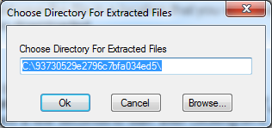

Change the directory if you need to and then press Ok.

Proceed through the installation program following the steps:

1. Select Installation from the menu on the left and then click on New SQL Server stand-alone installation

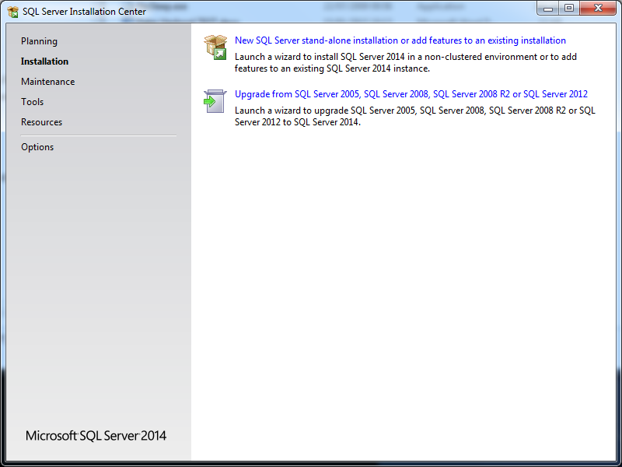

2. Accept the terms
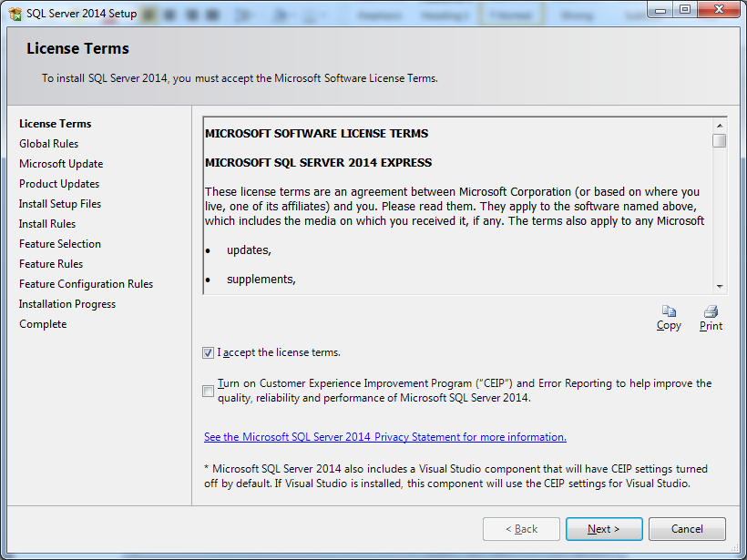
3. All features should be selected, with the exception of ‘LocalDB’. Press Next
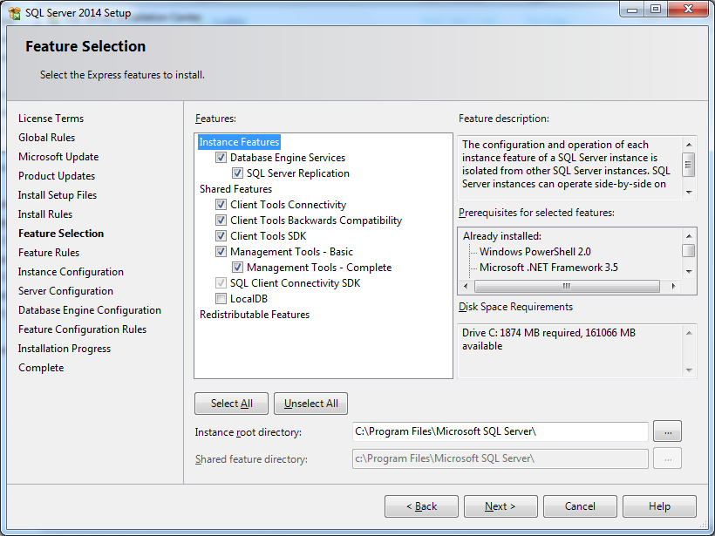

4. You should select Named Instance. If possible leave the instance name as SQLExpress, if you already have an instance of that name then choose another name ( e.g. SQL2014 ) and enter it. If you choose another name for the instance then please make a note of the name as you will need it for later use in updating the f2b.INI configuration file. Press Next
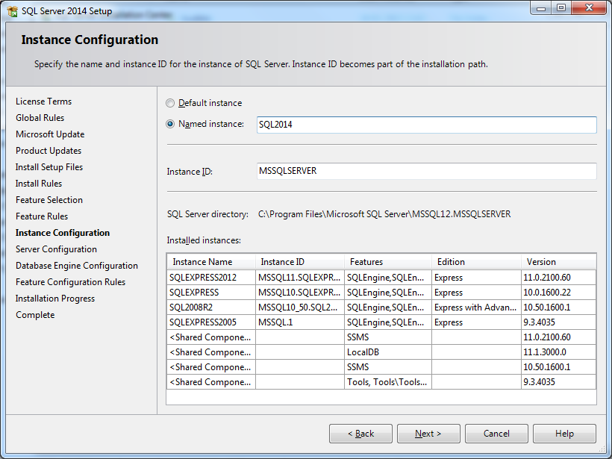

5. Specify the service accounts that you wish to use. If you do not know then you should use the suggested defaults. Press Next
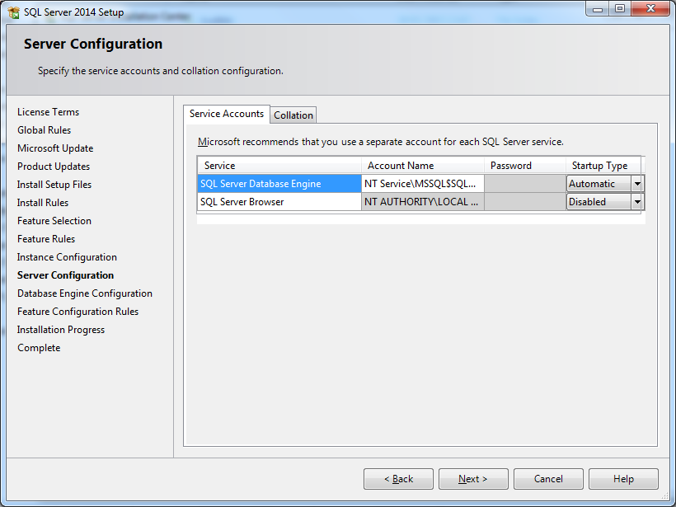

6. Select Windows Authentication mode and press the button marked Add Current User. If you are logged on to the machine as an administrator or are performing the installation on behalf of somebody else then you should also add the intended user to the list of SQL server administrators using the Add button. Press Next

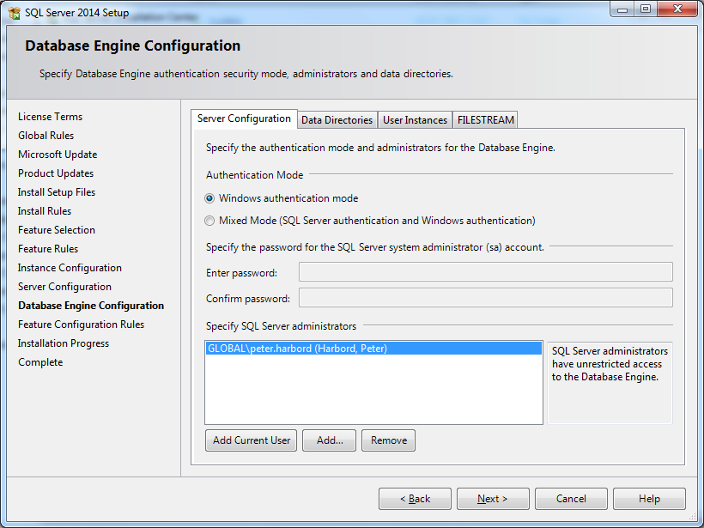

7. Wait for some time……
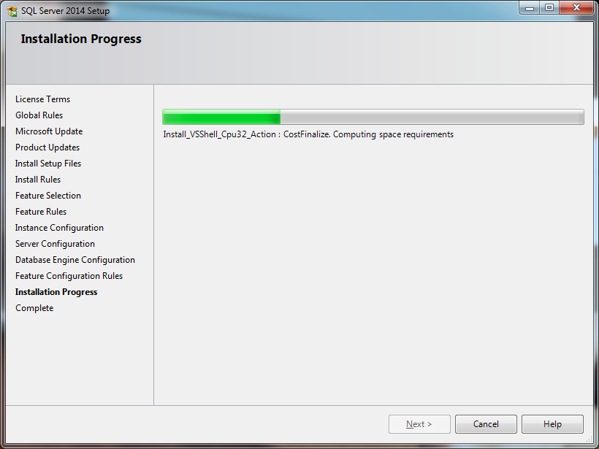

8. Press Close
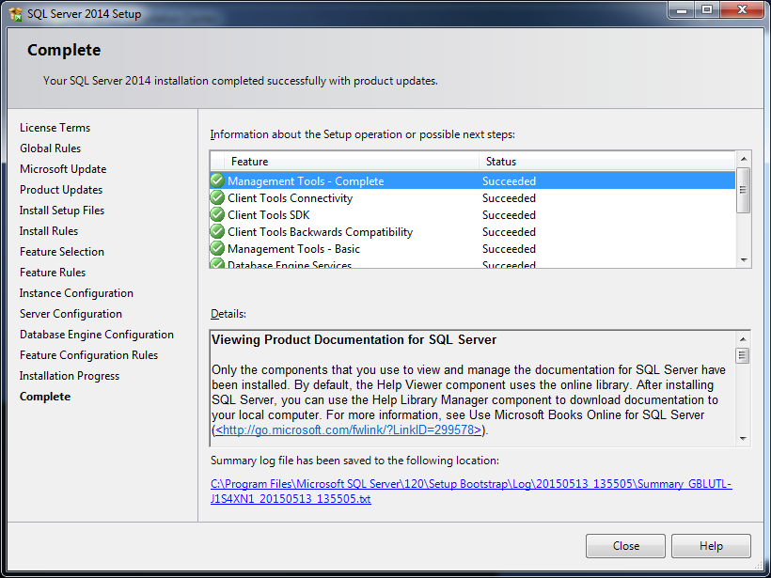
9. Close the SQL Server Installation Centre
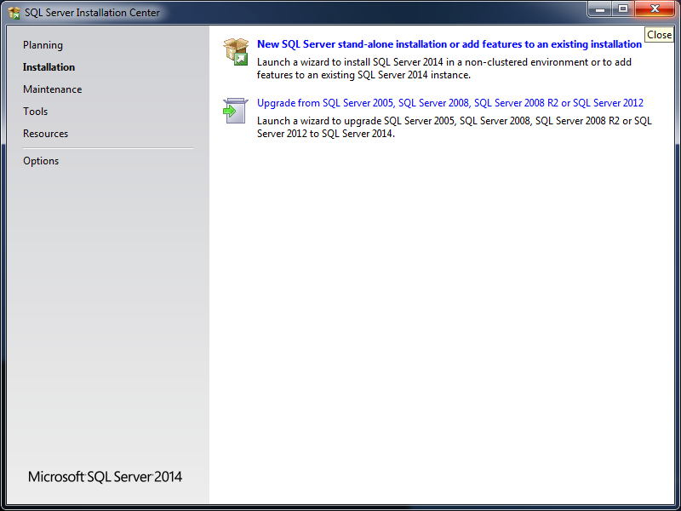

If you have a 64 bit PC you should go to the Start button at the bottom left hand corner of Windows, select All Programs → Microsoft SQL Server 2014 → SQL Server 2014 Configuration Manager.

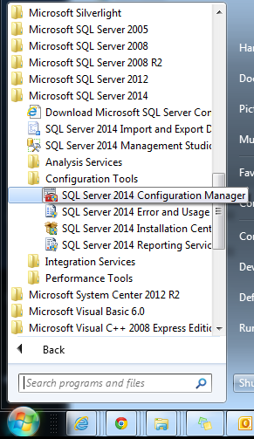

Click on the small blue triangles in the left-hand pane
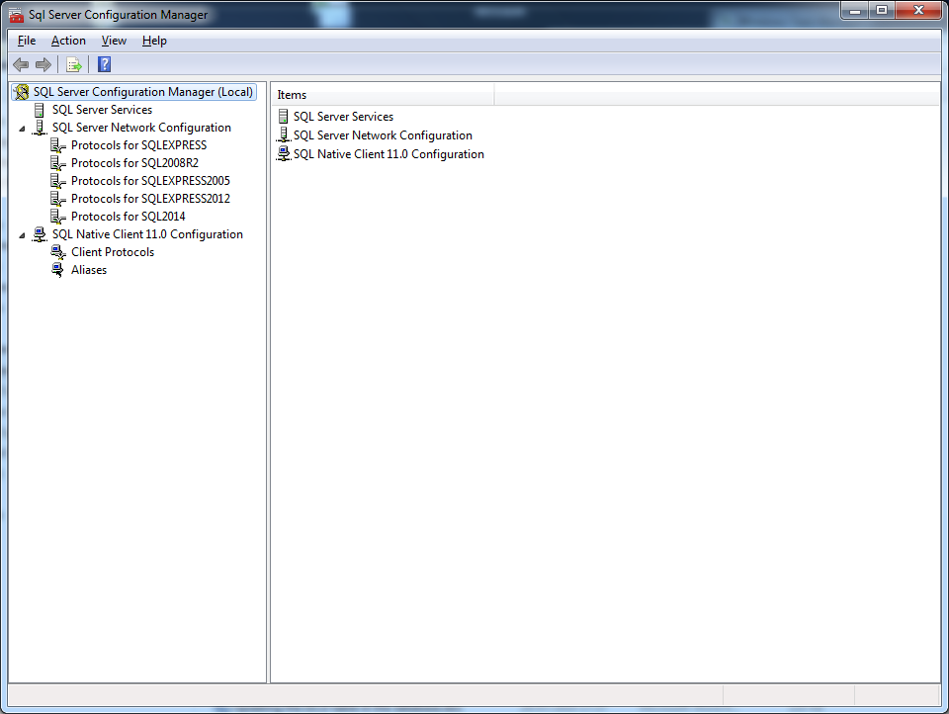
Select Protocols for SQLEXPRESS in the left hand menu. If you used a ‘Named Instance’ when setting up the SQL Server you should select Protocols for <your instance name>. In the right hand pane, right click on Named Pipes and select Enable. Press ok at the warning message. Do the same for TCP/IP.

Close the configuration Manager.

Go to the Start button at the bottom left hand corner of Windows, select All Programs → Microsoft SQL Server 2014 → SQL Server 2014 Management Studio.

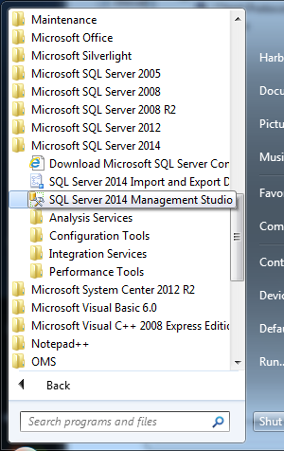

Enter the name of your SQL Server
Usually this will be your Computer name followed by \SQLExpress ( e.g. Hamish-PC\SQLExpress ).
If you used a ‘Named Instance’ when setting up the SQL Server you should enter <your computer name>\<your instance name>
( e.g. Office-PC\SQL2014 )
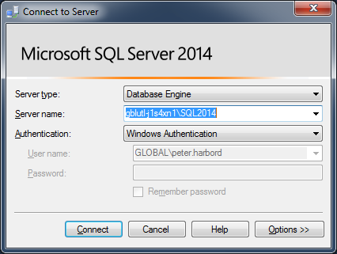

Press Connect.

Right click on the top line in the left-hand window in SQL Server Management Studio. Select Restart.

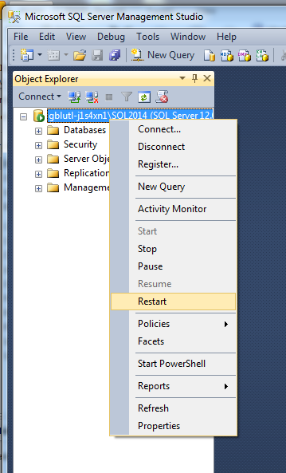

Press Yes in the subsequent screen
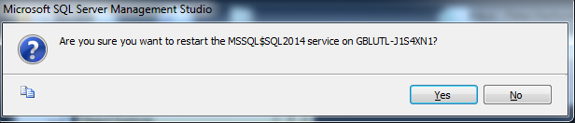

SQL Server 2014 has now been successfully installed and configured correctly for use.

